# California Adventures: Week One

Instead of racing along to get to my family like I usually do, this time I slowed things down and took some time to "smell the roses" as I drove from Salem, OR to Willits, CA. I am always curious about the interesting things I see along the way and it was so nice to pull over multiple times to check something out.

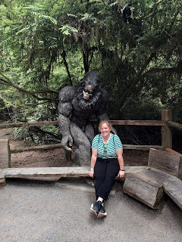

Sunday, July 23rd:

I had a 6 hour drive to get to my hotel in Crescent City, CA, but that was because I chose to add an extra hour so I could drive south along the Oregon Coast, something I had never done before. The best option was to cut over toward the coast near Eugene, OR and head west to Florence. Mike and Suzy recommended one of their favorite restaurants for me to have lunch in Florence, so I made that my destination.

Florence Harbor . . .

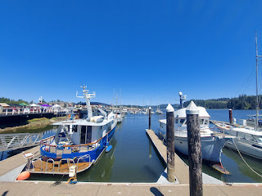

Florence, Louisiana??

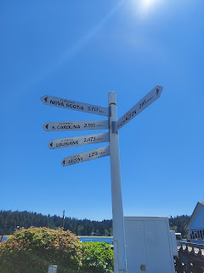

Lunch was pricy . . . but then it IS a coastal town . . .

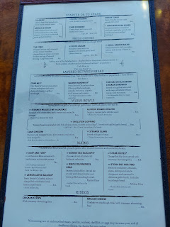

I ordered the blackened salmon atop a Caesar salad. It was delicious and was just the right amount. This photo makes it look much bigger than it actually was, though.

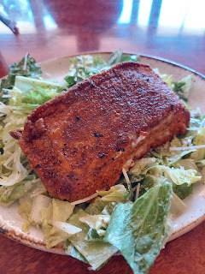

I pulled over to smell the fresh air and take in a beautiful scenic view point many times. Here are a few photos that I took . . .

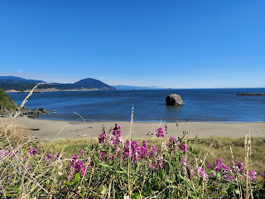

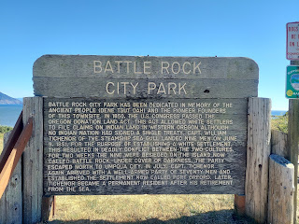

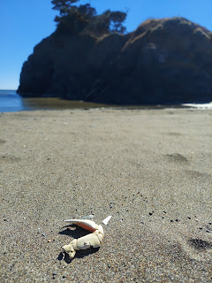

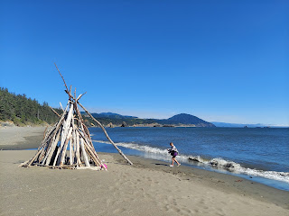

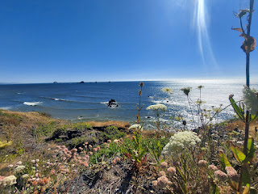

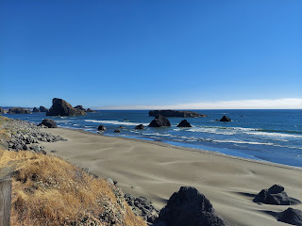

Video of the crashing waves somewhere in Southern Oregon: (12 seconds)

https://photos.app.goo.gl/Nj3XtxsDAg47THG69

The wind was pretty strong at this point, so it made for some spectacular and model-worthy photos. See and judge for yourself.

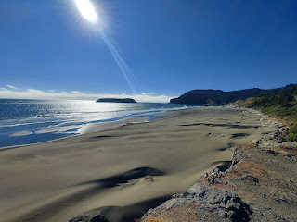

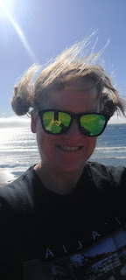

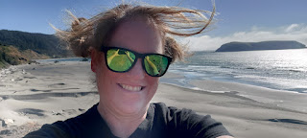

At one point, there was a sign for a trail to see "Whale Head Rock" or something to that effect. I pulled over yet again and hopped on a little trail through the woods to the edge of a cliff.

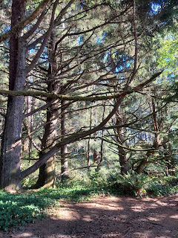

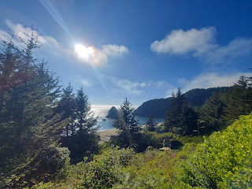

The trail went on further, but I didn't want to spend too much time, so I headed back to the car through the thick vegetation and on the slender footpath.

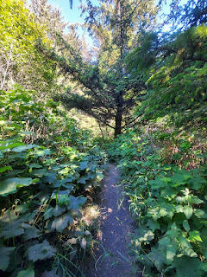

Finally, I made it to the California border!! Hooray!! Windblown and tired, I was almost to my hotel.

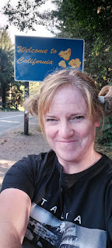

I stayed at the Ocean View Inn in Crescent City. It was an adequate place to lay my head for the night. The room was VERY spacious - I could have fit my entire family in there. The bed was comfy and I slept well.

Monday, July 24th:

The breakfast was pitiful, however. It included the minimal fixings of Frosted Flakes, Cheerios, bagels, yogurts, and juices. I didn't want any of those. Thankfully, I had a nectarine and a string cheese with me, so that's what I ate as I started my last big day of driving (for a while).

I went on a walk to the nearby Battery Point Lighthouse. I passed a very irate lady, who was yelling this and that, using F-bombs every other word, mostly yelling about the police, etc. She was venting to a guy seated on the bench next to where she stood, angrily hollering and getting everything out. I was troubled to hear everything she was saying, so I started praying in my mind: "Please bless her. Please help her to be comforted, to know she is loved, to feel at peace. Please bless ME to have charity, please bless me to feel love for her, etc." It was unnerving to start the day with that scene, but I hope she had a better day after she got all of that out.

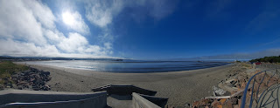

It was about a 20 minute walk to get from my hotel to the lighthouse, but what a gorgeous view!

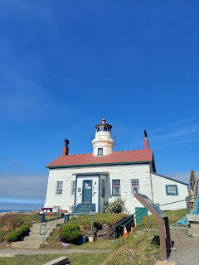

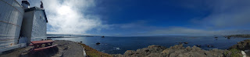

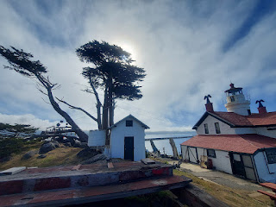

Video of the views from the lighthouse: (19 seconds)

https://photos.app.goo.gl/eYMx6vamZ8d2axt99

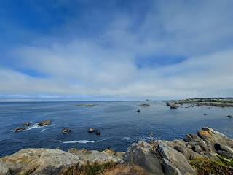

Just as I was leaving, a small group of Amish or Mennonite families arrived. They looked so happy to see the ocean and the views, just as I was. I couldn't help but sneak a photo as I walked past . . . I hope that was okay.

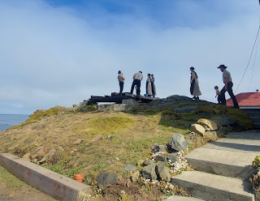

I had a long and comforting conversation with Scott during my entire visit at the lighthouse, and on the way back to the hotel. He is currently in Germany doing a targeting class for the next 2 weeks.

My first stop heading south was to visit the Trees of Mystery, something I have driven past numerous times and never stopped!! It was SO WORTH my time.

The legendary Paul Bunyan and his blue ox, Babe, are HUGE. They make it easy to find this place, since there wasn't any signage until right where the trees opened up on the highway and suddenly there it was.

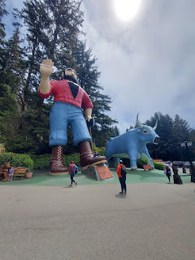

Some guy was probably sitting upstairs in a booth, watching the crowds walk past Paul B. He would speak calmly through the loudspeakers and his voice was welcoming. It would carry clear across the parking lot through the sound system. If someone was eating an ice cream cone and was sitting near Paul B., he (the guy pretending to be Paul B.) would casually comment on it, asking what flavor they were eating, etc. It was hilarious! And Paul B.'s gigantic hand would slowly wave from up high.

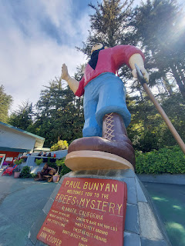

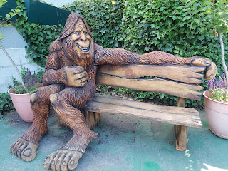

For just $25, I got to see a LOT. (Well, technically, I only paid $23 since I had a military ID card.)

There are all sorts of unique Redwood or Sequoia tree formations to see, like this one. The sign says: "These are the trees you have seen in Ripleys Believe It Or Not."

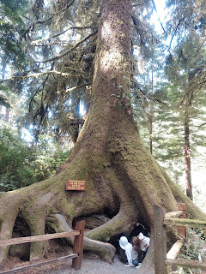

This next sign says: "The burl tree snapped at the burl at night during a windstorm on January 16th, 2016. Nobody heard it fall."

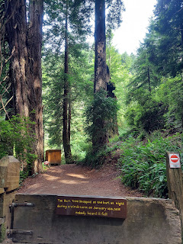

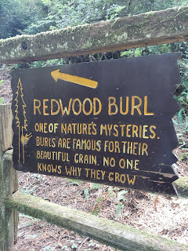

Here is a closer view of where it snapped and fell. It's hiding behind another tree.

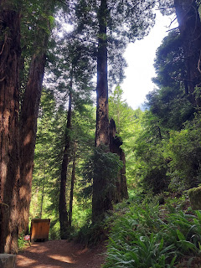

3 - in - 1 Tree . . .

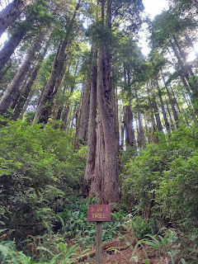

I was eager to try out the Canopy Trail, a series of suspension bridges hanging from mid-canopy height amongst the giant trees. You go from tree to tree, where there is a secure platform once you have crossed the "air" in between.

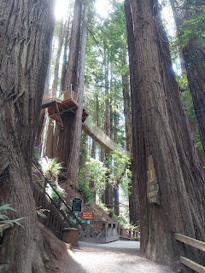

Yoda is there to wish you well as you begin traversing the first suspension bridge. Thank you, Yoda.

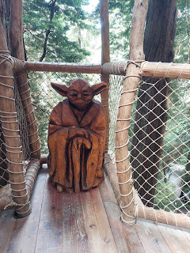

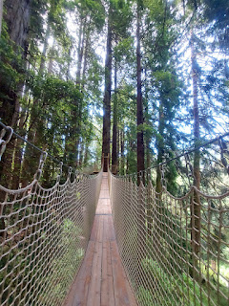

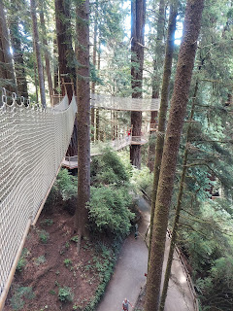

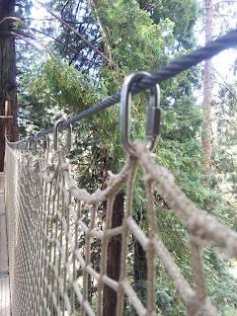

The bridges between tree platforms are approximately 100 feet above the ground. Yes, there is a little bit of a bounce as you walk. Yes, they are secure. And yes, there was still a little bit of a woozy rush going on in my head, even though I felt secure.

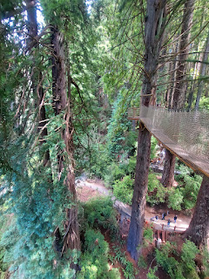

These trees were conjoined where the platform sits. I thought it was very interesting . . .

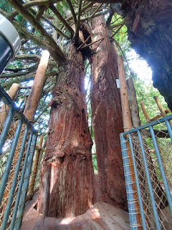

I found a nice family from Twin Falls, Idaho to take a photo of me. I always offer to take other people's photo first, which opens the door for an opportunity for myself afterwards. :)

This set of trees (below) carries some significance. The sign behind me in the photo reads:

"This is their temple, vaulted high,

And here we pause, with reverent eye,

With silent tongue and awe-struck soul,

For here we sense life's proper goal.

"To be like these, straight, true, and fine,

To make our world, like theirs, a shrine;

Sink down, oh traveler, on your knees,

God stands where you are in the trees."

The sign on the left explains that this is a living monument, dedicated to Joseph B. Strauss.

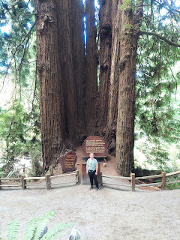

I "saw" an old saw, stuck in the base of a giant Sequoia tree . . .

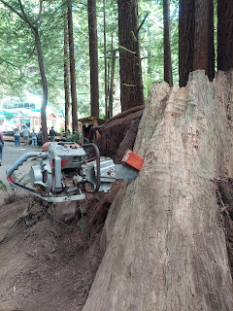

If you look closely at the next photo, you'll see more than one saw . . .

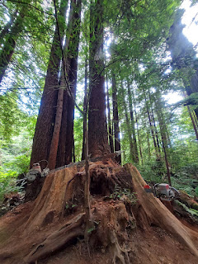

The entrance fee also includes a new(ish) gondola ride, where you can glide up the mountain ABOVE the extreme heights of the Redwoods and Sequoias. Six people can ride in each car, and two gondola cars come around every few minutes to scoop you up.

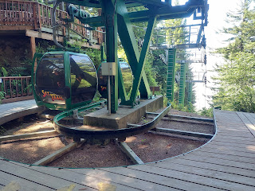

The view at the top was a bit obscured - "I can't see the forest for the trees . . ." There is a large viewing platform, but the view itself wasn't overly impressive to me.

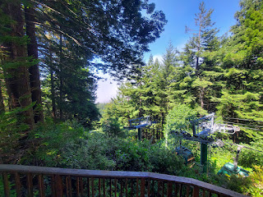

There is a Wilderness Trail to get back down to the bottom if you so choose. It's about a mile and is described as "not for beginners". I heard the gondola attendant saying that the first bit is almost straight down, before it levels out and then has some ups and downs closer to the base. I did not choose to go down the trail, mainly because I was not wearing suitable shoes for such an endeavor.

Views heading back down . . .

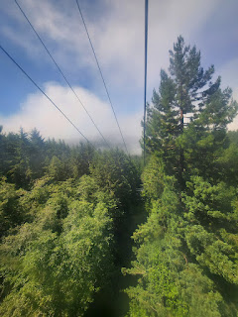

Video of a portion of the ride back down in the gondola: (31 seconds)

https://photos.app.goo.gl/Azf3jq9TV5pLbrFs8

I back-tracked down the trail, once I got off the gondola, because I wanted to see the Brotherhood Tree. It's one of the oldest trees still living . . . And it's dedicated to the "Brotherhood of Man: All races, creeds and colors."

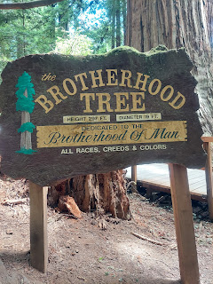

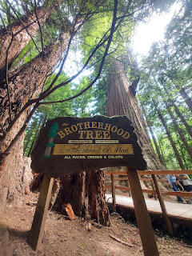

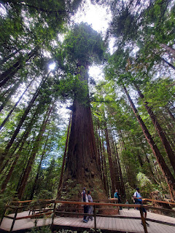

It was beautiful just to walk along the trail system throughout the park.

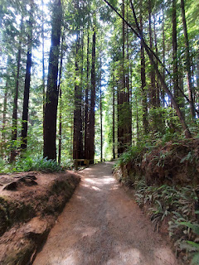

This is the Baby Cathedral Tree . . .

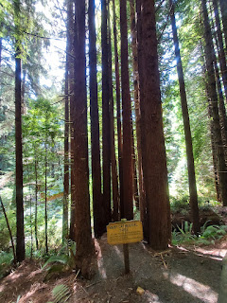

This next photo explains it all in a humorous sign:

"Baby Cathedral Tree. We are taking reservations for weddings when this display is ready 600 years from now. You can see here how cathedral tree (sic) is formed."

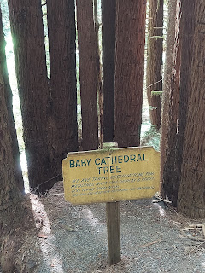

I loved the explanation for the Candelabra Tree. I would love to find a way to incorporate this idea into a church talk . . . (click photo to be able read the sign)

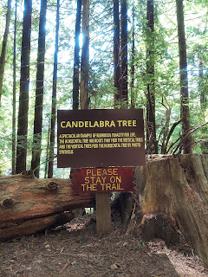

The Candelabra Tree . . .

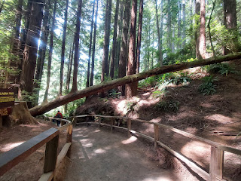

The last section on the trail was called "Trail of Tall Tales", a collection of wooden sculptures meant to portray people, items, and other features from Paul Bunyan's growing up years. The sculptures were made from local artists who worked with a chainsaw, an axe, and a chisel to accomplish their works of art.

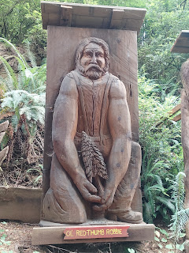

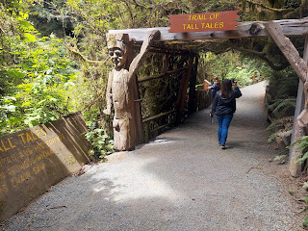

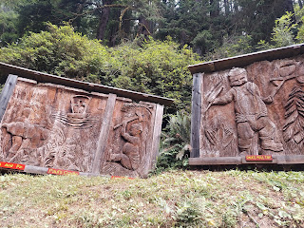

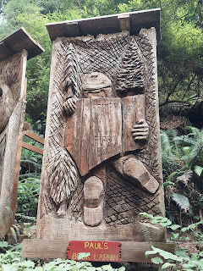

This next one might be hard to recognize at first, but it's a giant dog's head and he's eating a "bone".

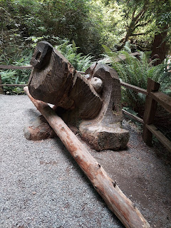

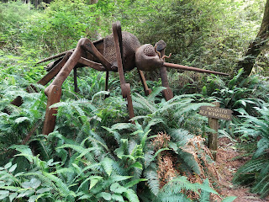

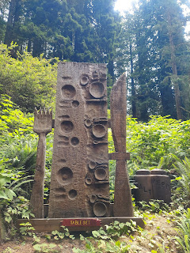

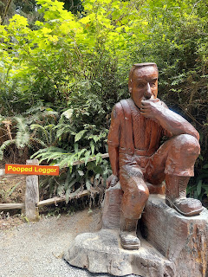

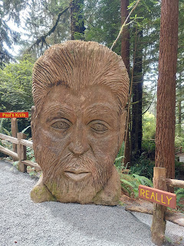

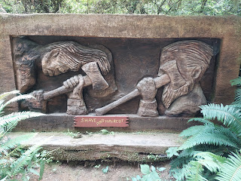

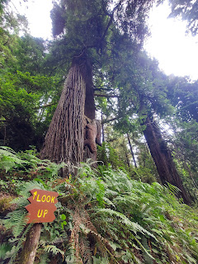

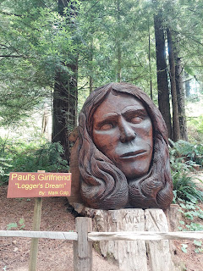

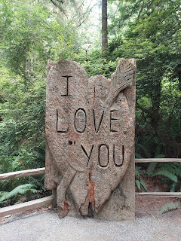

At the end of the trail, I had my picture taken with Sasquatch. LOL



This cross section of a Sequoia tree was right next to the Gift Shop and exit. It shows how when the tree was "born", the Crusades were taking place in 1096. It also shows the aging of the tree with markers for the Magna Carta (1215), Columbus (1492), Pilgrims (1620), and Independence (1776). What a fascinating way to connect the history of a tree with the history of the world!!

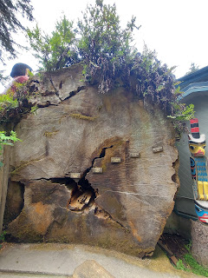

Good advice: "A Giant Sequoia's Guide to Life" . . . (click photo to enlarge and read)

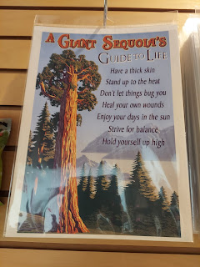

I bought a few things in the Gift Shop and then off I went down the road again. I spent about 2 hours visiting the Trees of Mystery and I enjoyed every single minute!!

My next stop was in Trinidad, CA to fill up with gas and get lunch. (I realize how that sounds . . .)

I made a bad choice in taking the Patrick's Point exit (slightly north of Trinidad) - which led  me NOWHERE, except for an endless narrow road on the edge of a cliff, and included several horrible spots in the road where it was chunky rocks/dirt/gravel instead of pavement and also several areas of warped pavement that I could not believe I had to drive over oh-so-carefully so I didn't ruin the underside of my car.

Eventually I found a way to get back to Hwy. 101 and soon I made it into the actual town of Trinidad. The Patrick's Point exit was misleading because it said Trinidad on it, and it also professed to have food offerings. I think they lied . . .

I didn't have any internet to make an educated choice on where to eat, so I just found a place to park after I filled up the car with gas and walked to a nearby restaurant. It was called Trinidad Bay Eatery. It was super busy and I had to wait about 20 minutes just to get a table for one. The lunch options were pretty spendy, but I was hungry and I was already there, so I chose the Tuna Melt sandwich with a little serving of slaw. The sandwich was great. The slaw was meh.

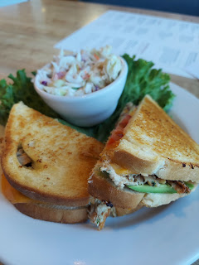

I went for a little walk after lunch, trying to find the trail down to the beach that I remembered from a few years ago. I couldn't find it, but I did find some gorgeous California poppies and a lovely view of the harbor.

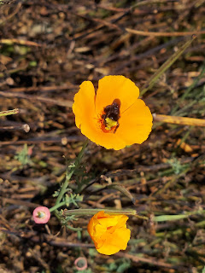

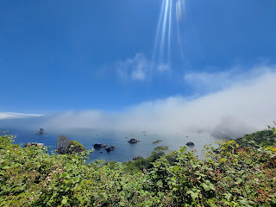

I called my Dad before I started driving again, just to review how to get to their house in the forest. I always get stressed when I try to drive there because there is absolutely zero cell phone reception once you leave Hwy. 101. It's also dark and somewhat spooky at times, it's easy to get lost, and there's a BEAR in their neck of the woods. So I got some good instructions from Dad and then I headed south some more.

I always love to take the detour known as Avenue of the Giants. It's a beautiful and slower road adjacent to Hwy. 101 that meanders through the Redwood forests. There are several places to pull over and just hop onto a trail.

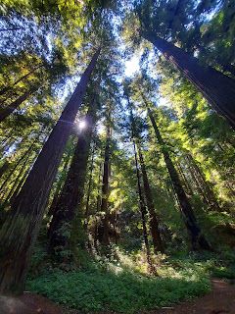

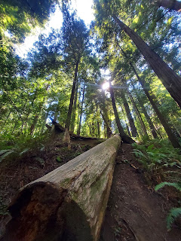

There was nobody around, but I wanted a picture of me in the forest. So I set my phone down next to a log and turned on the 10 second timer on my camera app. I tried a few times until I got one that I liked, ha ha.

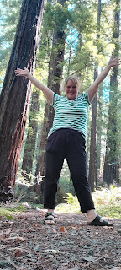

The spot where I pulled over had a nice paved parking lot, right next to the trails leading into the forest.

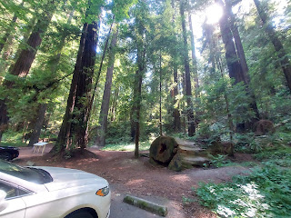

That was my last stop before I reached the turnoff for my Dad and Michelle's house north of Willits. I remembered him saying to follow the signs for 28701 (which is their house number), but to also be sure to take the road on the right at one point as I got close to their driveway. From where you turn off Hwy. 101, it's about a mile back into the forest on a dirt road before you reach their house.

I did great until the very last moment. I had to make a split decision where there was a fork in the road. I knew that I was supposed to follow the 28701 signs, but I also knew I was supposed to take the road to the right as I pulled up to the house. So I took the road to the right.

That was the wrong decision. In fact, it was a very bad decision.

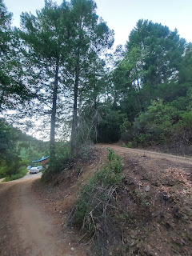

The road went UP immediately. I went around the corner and it went from steep to VERY steep!! I instantly knew that I was on the wrong road, but there was no place to do anything about it! It was very narrow and my front tires were starting to spin out because they couldn't get any traction. I freaked out pretty quickly.

I stopped the car, and with a racing pulse, I cried out to my Heavenly Father to please help me get back down. I tearfully began backing up, one inch at a time, using my backup camera and my left side mirror. I was most concerned with the sharp cliff on my left, so when my backup camera started beeping at me as I crept too close to the shoulder on my right, I didn't care. I let some branches scrape the side of my car twice because I'd rather have that happen than to roll down the cliff onto my Dad's house below.

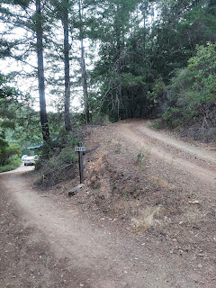

Eventually, I was able to back down successfully, even though I slid a couple of times due to the steepness. I pulled into the CORRECT driveway, where Michelle came out to greet me. I melted into tears as her arms pulled me into a hug. It took a while to bring my heart rate down as the adrenaline wore off.

As it turned out, my Dad and I just missed each other as he went out to look for me. He knew what time I would be arriving, so when I didn't arrive, he drove off to find me. I saw him drive off as I was backing down the hill next to him, but he didn't see me . . . until about 30 minutes later he came back to learn that I had arrived "safely".

The mixup had to do with this: in the photo above, there is a sign that says 28701 just as Dad had instructed me. If I had just followed that, then when I came around the corner toward the house, THAT'S when there is a split and THAT'S where I was supposed to stay to the right. Whoopsies.

Good thing I'm staying here for TWO WEEKS so I can practice getting it right -- for the rest of my life!!

I checked the right side of my car for scratches, and thankfully it wasn't too bad. I'm just glad I made it down that scary road . . . what an entry, ha ha.

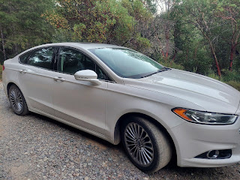

Tuesday, July 25th:

We drove into town (Willits) to meet my sister, Melanie, and her kids, Caleb and Mandie, who were in the area visiting our parents. We chose to meet at a local park that's also named after my Dad's first cousin, Ernest "Bud" Snider. ("Bud" is the son of Ernest Alvin Snider Sr. and grandson of William "Al" Snider and Sarah Jane Baugh.)

Bud Snider was the pastor of the Willits Community Church from 1968 until the year before he died in 1993. He also worked as a Public Works supervisor for many years. I thought he sounded like a really fun guy when I read in his obituary that he dreamed of being a cowboy in his youth, and even participated in several rodeos as a young adult.

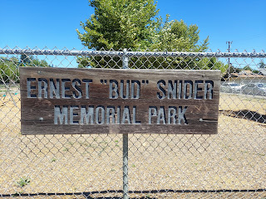

I love this photo of my Dad and stepmom, Michelle. Not only are they two beautiful people, but they are strong and resilient like the Redwoods behind them. They lead not only by example, but they dig in and serve so many people in whatever ways they can. And just like the trees, they are stalwart and majestic, and have a toughened outer shell to help them weather whatever life throws at them.

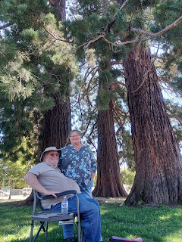

We ate lunch together and visited for about two hours before Melanie and the kiddos needed to head back down to Ukiah. It was really fun to laugh and chat and hang out for a while. :)

Clockwise from Dad in the upper left: Dad, Caleb (leaning on his mom's head), Melanie, Me, and Mandie.

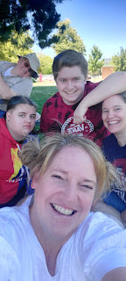

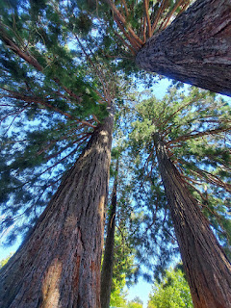

After I took a photo looking up into the Redwood trees, I took a photo of Caleb following suit.

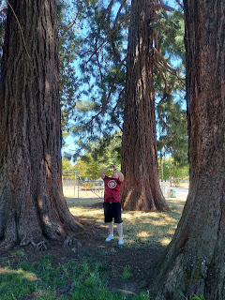

Relaxing time on the picnic blanket in the shade . . .

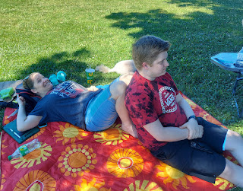

After lunch, Dad and I went over to their current house project on Margie Drive to get some work done. They are renovating the entire interior to sell the house. The recent renters took horrible care of the house and now it is requiring a TON of work to prepare it for new owners. They have replaced flooring throughout, and in some cases, new drywall and walls. Everything has been slowly repainted and put back together.

I helped caulk some rooms where the new flooring meets up with the walls, so that all the baseboards can be put back on soon. When Michelle got back from teaching (summer school at the college in Ukiah), I helped her out back with a daunting and tedious task.

The previous renters broke some of the tiles surrounding the woodstove in the family room, but rather than start all over and buy new tiles, we are trying to work with and repurpose the tiles that are already there. In order to reapply them, we have to scrape off all the old mortar first . . . it's not an easy task.

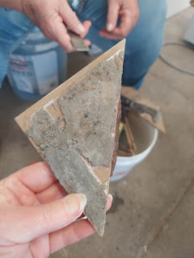

That little piece of triangle has been the bane of my existence these past few days. I WILL conquer it, though. It takes a good amount of soaking in some water each night, then a lot of scraping with a variety of tools, and a whole lot of patience. I AM making some progress, and I will show you the final results when it's eventually done.

Michelle and I enjoyed visiting while we scraped and dug and scraped some more.

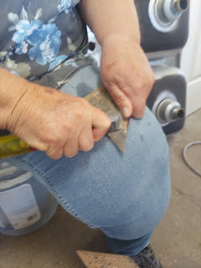

At the end of the evening, and after dinner, I accompanied my Dad to dump some food scraps a ways down the road from their house. They don't have a garbage pick-up service, and they can't just store their trash in a can outside. Not with a bear in the "neighborhood" and now a pack of rats that have started foraging near the house.

This weekly trip down the road is known as "feeding the bear". While we're not sure if the bear is actually eating the scraps, someone sure is . . . it could be the birds, or foxes, or raccoons, etc.

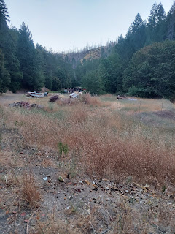

Wednesday, July 26th:

Back at the Margie house, Michelle and I decided to pick some blackberries in the back yard. The wild bushes will soon be torn out to clean up the yard to make it more appealing to a prospective buyer, but with so many ripe berries at the moment, it would be a shame to let them all go to waste. We each had a bowl, and got to work in separate areas.

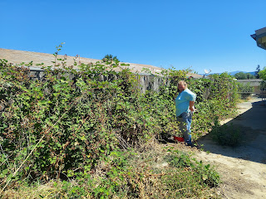

I focused mainly in the area close to the shed on the left, using an old wooden sawhorse as my stepstool to reach further up and out . . .

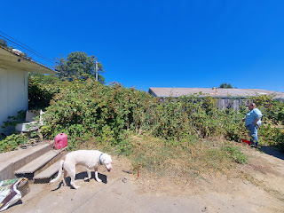

I found a great little stick to help gather up the spiderwebs that were all over and in my way . . .

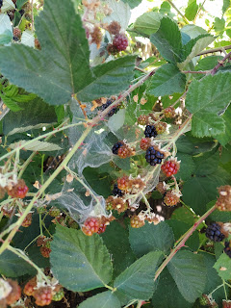

I just had to keep an eye out for the spiders that began retreating as I entered their domain. Blech.

After picking berries for a while, getting nice and sweaty, I changed my clothes and headed down to Ukiah to see my Mom and Grandma Doris. We met at Dalistan Care Home, where Grandma is getting such good care still.

I later learned from my Mom that Grandma was unusually perky that afternoon, and we were both surprised that she recognized me right away and even said my name! Mom and I took turns sitting next to her and then sitting over on the bed so the other one could visit with her up close.

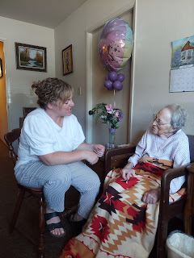

For some reason, she began using sign language as part of her communication that day. When I helped her hold a glass of water and take some sips, she showed us the sign for water. (holding up 3 fingers to represent a "W" and then gently tapping your fingers to your lips) This led to Grandma and me doing the entire sign language alphabet together.

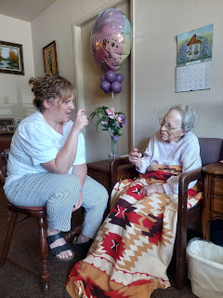

We clapped when we finished. And thankfully, Mom captured these precious moments for me.

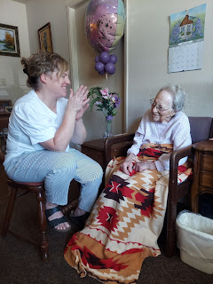

I took several videos during our visit with Grandma. I know she wasn't "at her best", but I also know that it's important to capture in real time the moments that we DO have with our loved ones.

Video #1: A chat about how Grandma gets her hair done. (29 seconds)

https://photos.app.goo.gl/rhB3udXeTVZP1n2v8

Video #2: First time through - singing "Old Spinning Wheel". (1 min, 22 seconds)

https://photos.app.goo.gl/x3B1bypcEJvyDJQi6

Video #3: Mom - in a cute blooper - ad-libbing as she realized she didn't have all the right sheet music. (21 seconds)

https://photos.app.goo.gl/gDWLrsVHbdJTdfvS6

Video #4: A more polished version of "Old Spinning Wheel". (39 seconds)

https://photos.app.goo.gl/3XMsay5a7VhsRGA76

Video #5: Singing "Yes, Jesus Loves Me", a favorite song from Grandma's childhood. (43 seconds)

https://photos.app.goo.gl/DKQ9ZhzyPWU692CH7

Video #6: Grandma trying to spell her name, Doris, in sign language. (41 seconds)

https://photos.app.goo.gl/dGpxHpezoYgw4K2W9

During the last portion of our visit, we took down Grandma's favorite painting off the wall so she could see it and touch it. She used a mixture of words and sign language to describe to us how this scene was something she created in her own mind, but a few of the objects were "copied" from other reference points. (such as the gate)

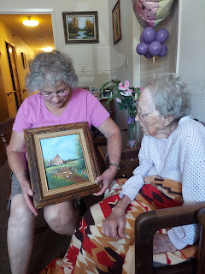

She ran her fingers over the painting several times, reminiscing back to when she actually had the paintbrush in her hand, doing the brush strokes. We could tell it brought back happy memories for her.

I'm so glad I got to visit her again, something I didn't ever think I'd be able to do. Last summer, I had a strong impression that I wouldn't see her again in this life. But I did! And I'm so grateful. :)

Thursday, July 27th:

We worked on the Margie house for a good portion of the day. I finished painting the bathroom for Michelle, after she did some prep and trim work the day before. I was determined to make the last little bit of paint sufficient to finish the job, and I had to be strategic during the process. I was very selective about where to apply more generous amounts of paint, versus where to skimp and save. Thankfully, there was already a first layer of paint on all the walls, so this second layer was to freshen everything up.

Because I was extra careful in how I used the tiny bit of paint left in the bucket, I was able to finish everything in the bathroom with pretty much nothing leftover . . .



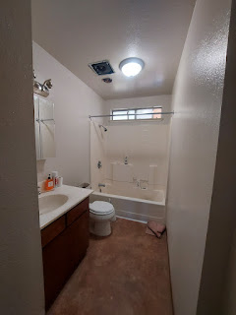

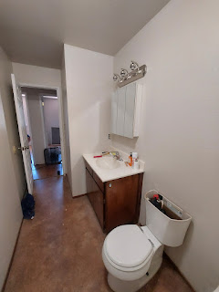

Dad took me out to lunch at his favorite Mexican restaurant in Willits, La Cocina. It was really tasty!! We had chips and salsa, and I ordered the Pollo con Mole.

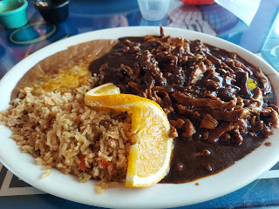

After lunch, I did some cleanup with the shop vac, slurping up dust and mess all over the house. At one point, I walked past where my Dad was sitting and noticed he was sound asleep. What a cutie!

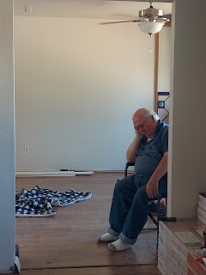

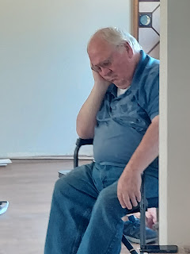

While he snoozed away, Michelle and I sat out on the back patio for a while, scraping/digging/cleaning those darn fireplace tiles again. We made some measurable progress, though, which was satisfying. Another analogy for life: even though something might seem impossible and tedious at best, just keep chipping away at it. Eventually you'll be able to see some progress, however small.

Friday, July 28th:

I had a nice long video call with Scott, where we caught up on several things. Some days, we only get to talk for a few minutes and that's it. It's even harder to connect now because we're 9 hours apart, instead of the usual 8. That means that we have even less time during the mornings (for me) before it's bedtime for him!

I went down to Ukiah to spend the afternoon with my Mom and my niece, Ana (Charmaine's daughter). Unfortunately, Ana didn't sleep well the night before, so she wasn't able to join us.

I went with my mom to the nearby health club to swim and tan all afternoon. What a treat!

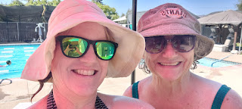

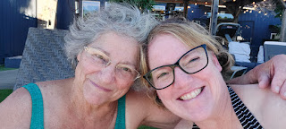

We alternated between doing laps in the pool and then laying on the lounge chair to soak up some sun and/or read. Mom is always such a graceful swimmer and I'm so proud of her for trying to stay fit all these years. I'm not as good of a swimmer, and I didn't want to get my hair wet if I could help it, so I chose to do my laps by "walking" or bobbing down the length of the pool and back. Sometimes I would hang out near the steps and do other forms of exercise, like underwater bicycling or tricep dips. It just felt so good to be in the water as a whole!! The day wasn't too hot, but it was toasty.

We chatted quite a bit, too, which was nice. We stayed until after 6:00 before we drove back to her house and made a salad together for dinner. We had a wonderful day!!

Saturday, July 29th:

After a short chat with Scott, I drove into Willits with Dad and Michelle to get to work on the Margie house again. Michelle and I spent some time out front, cleaning up a flower bed, clearing out some miscellaneous garbage up against the house, and trying to figure out the best way to prep for cement and brick next week. She wants to mix up and pour some cement to lay a foundation for a brick "pad" in front of the living room and up against the front of the house.

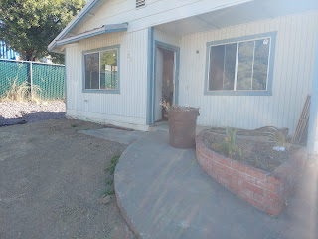

The brick pile . . . just waiting for us to begin . . .

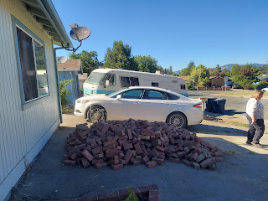

After we got good and sweaty working outside for a while, we switched gears to doing some inside chores. Michelle used a flat-blade scraper to carefully remove some accidental silicone residue that someone left behind when they came to help out recently. It had inadvertently been smeared too far out onto the flooring and won't be covered up by the baseboards when they get put back on, so it needed to be scraped up. Tedious, but necessary . . .

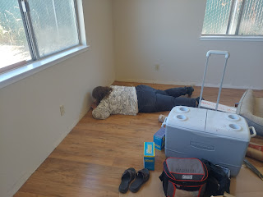

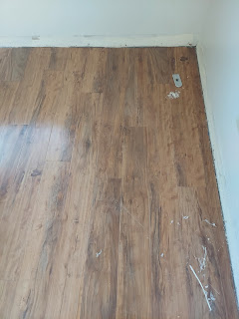

Meanwhile, I had a can of white paint and I went from door trim to door trim, either touching up missed spots, or painting the whole thing if needed.

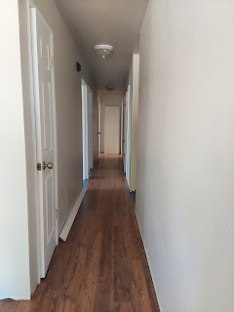

I also painted both back doors, but just on the inside for now. When the outside gets cleaned up and pressure-washed, then the outside of the doors can be painted eventually.

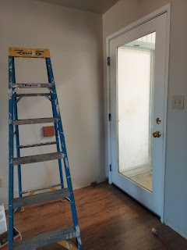

This is the only shot I got of my Dad that day, ha ha. He was just finishing up changing out an electrical outlet box by laying on the floor, since that's easier on his back.

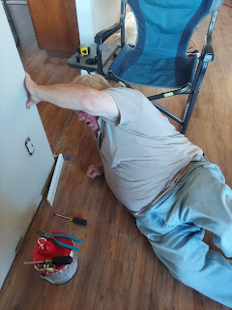

We headed back into The Forest around 7:00 p.m., barbecued some chicken for dinner, partnered up with steamed purple cauliflower and corn on the cob. Delicious!

Sunday, July 30th:

Happy Birthday Jacob!! I can't believe he's 27 years old now . . .

This was him on his 2nd birthday . . .

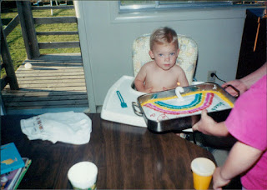

Jacob, sleeping with little Benson, who apparently liked to sleep face down . . .

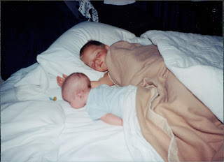

A numbers guy at an early age, just like his father . . .

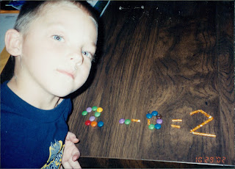

Always the clown in the family . . .

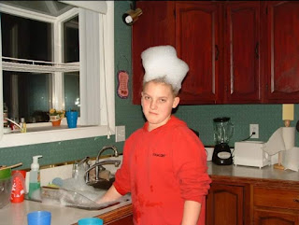

Scott was wrestling and having fun with the kids before he left for Iraq the second time in 2010. We took lots of pictures of normal, everyday things so we could refer back to them often whenever we missed him.

L to R: Jacob, Scott, Benson (with the crazy eyes), and Amber

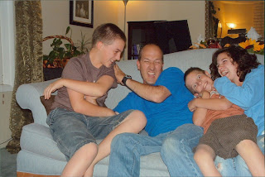

Jake and Hannah on their wedding day in 2019

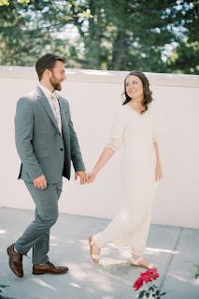

And now he's a proud and loving papa himself . . .

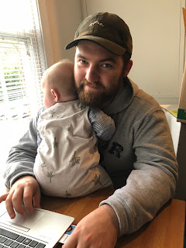

On Sunday morning, I woke up with a swollen gland in my throat, feeling tired, and wishing I didn't need to get out of bed. Thankfully, as the day went on, I felt better and not worse. I went to church in Willits this time, when I had originally planned to go to church with my Mom down in Ukiah, but she has been feeling under the weather, too. I hope she gets better soon, like I seem to be . . .

I was able to see (and hug) an old friend at church today: Gloria Urich. She used to be one of my young women leaders at Girls Camp when I was a teenager. She is an unusual lady, but so amazing at the same time! She is outspoken, sometimes too loudly, and can even make you feel uncomfortable at times with what comes out of her mouth. But

more

than all of these things, she is kind, she is spunky and full of grit with whatever life throws at her, she has the ability to see the bigger picture (most of the time), and wants more than anything for everyone to be given the benefit of the doubt. She is an advocate for those who need it, and she seems to lean more toward the mercy end of things, more so than the justice side.

For example, I thanked her for being one of those people who always made me feel loved and accepted as a young lady. We talked about a situation where there was a tricky situation at Girls Camp, involving some of my friends (38 or so years ago). She said it's more important to LOVE the girl than to DISCIPLINE the behavior.  And that's so true!! Even though I'm a huge advocate for that same philosophy now, I wasn't always so good at preaching love over discipline as I raised my kids. I'm pretty strong on JUSTICE, and in many cases I overlooked MERCY and LOVE. I am learning, however, and feeling better about the direction I'm headed in life. Thank goodness for change and repentance and life lessons and good examples to follow! (The best one of course = Jesus Christ)

On a side note, Gloria has had so much to overcome, especially in the last year or two. She had a significant stroke and has also been suffering from some severe depression, causing her to contemplate suicide more than once. And yet, she still shows up to church, she still gets work done each week, and still makes people laugh. She also has a family of 14 bears out on her VERY remote property. She told me today that Simon will eat out of her hand, Big Daddy shows up once a year to let her know he's still around, and whenever a new momma has cubs, she brings them over to show Gloria. Whaaat???

Some Final Items . . .

I haven't uploaded photos of my grandchildren in a couple weeks, so I will attempt to catch up now!

Jack - up in a tree in his new hometown of Minneapolis . . .

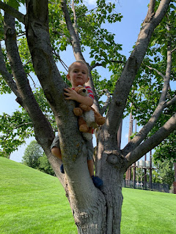

On a plane to visit family in Idaho and Utah recently . . .

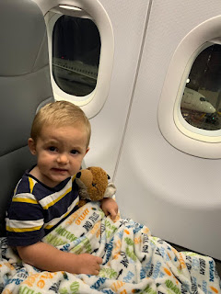

Fun with cousins on his mommas' side . . . (Jack is on the far right)

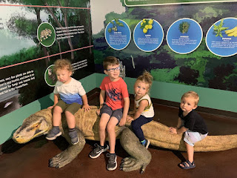

Independence Day in Scipio, Utah . . .

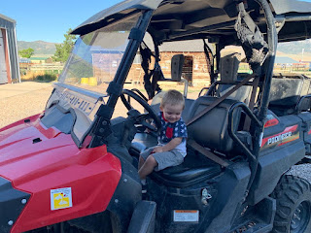

Livin' the dream with Grandpa Bob on his tractor . . .

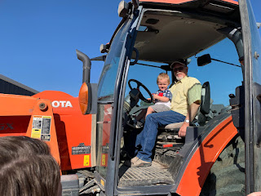

This could literally be on a postcard . . . how cute is this?!!

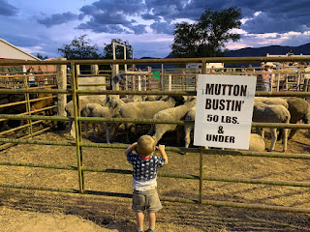

Back in Minneapolis now, and hanging out at the FREE zoo in town . . .

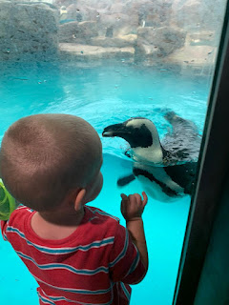

Meanwhile, Amber and Weston took the girls down to South Padre Island, Texas for the weekend. I looked it up on the map, and it's quite a drive from their home in Louisiana! (About 8.5 hours) It's south of Corpus Christi and very close to the border of Mexico. But it looks like they had a super fun time!!

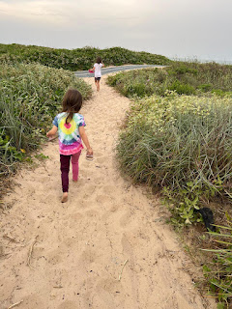

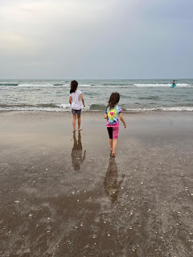

Gwen, Abby, and Amber

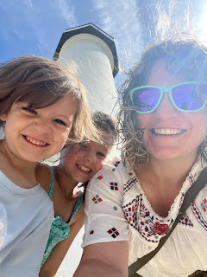

Amber recently got her hair done with blonde highlights, similar to mine. So now we really are twinnies!

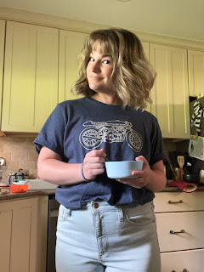

And back at the ranch (my house), Benson spent a fun afternoon with his daughter, Avery, on Saturday. I wish I were there to squish that cute little redhead, too . . .

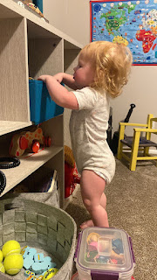

Looking ahead: I'll be helping in a variety of ways this next week at the Margie house. We plan to pour cement out front, lay some brick, and reinstall all the baseboards throughout the house. The Rawles Family Picnic is also scheduled for next Saturday - I hope lots of people come! I also look forward to visiting a couple of friends in Ukiah and spending more time with my Mom. Should be a great week!